Amar Adam Benadjaoud
Kellianne Laws
Begüm Sozer
Report Machine Learning

Project Description: Combining KNN Classification and K-Means Clustering
Our project is about creating a Python script that uses Supervised Learning (KNN classification) and Unsupervised Learning (K-Means clustering) to analyze datasets. The goal is to understand the data better and get meaningful results using these machine learning techniques. Below, we’ll break down how the project works step by step.

Foreword:
Before starting our study, we had to make sure that the database we chose was a good one, if there was a correlation between its data. That’s why we computed the correlation matrix of our database to see on one hand if a study would have been relevant and on the other hand to allow us to know which pair of features to use for our study.
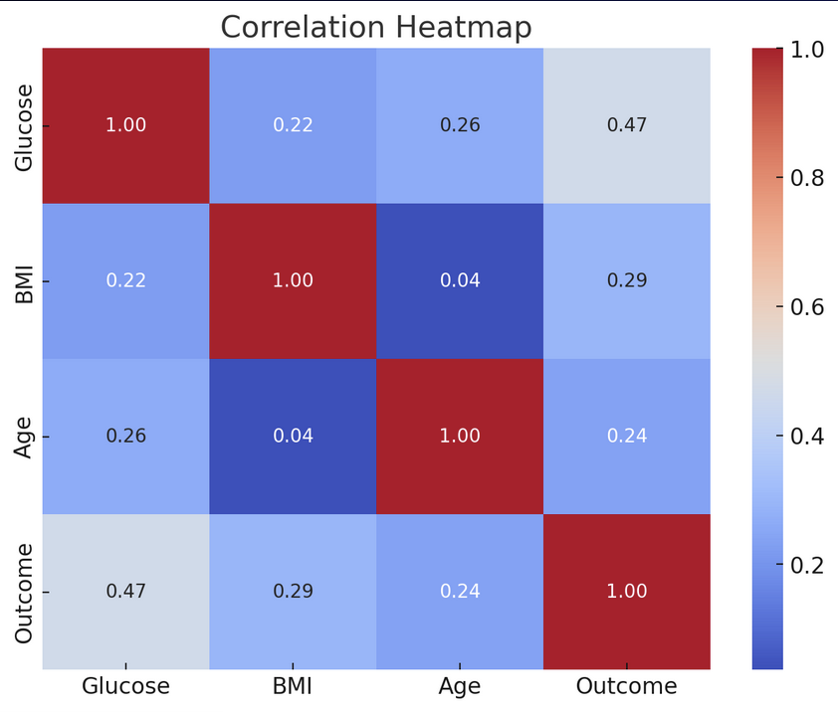
Step 1: Loading the Dataset
The first thing the script does is let the user choose a dataset in either .xlsx (Excel) or .csv (Comma-Separated Values) format. This flexibility makes it easy to work with different types of data. If you try to load a file that isn’t one of these types, the script will give you an error message so you know to choose the right format.
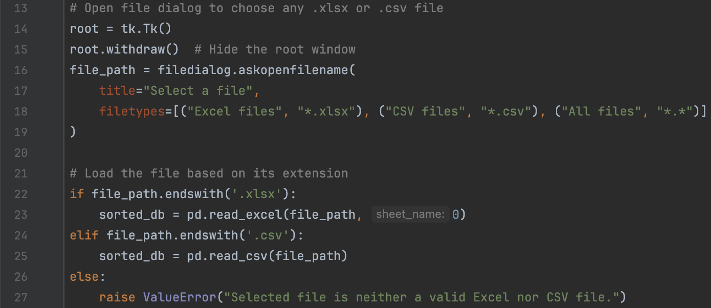

Step 2: Handling Missing Data
Sometimes datasets have missing values, which can cause problems for machine learning models. To fix this, the script automatically fills in any missing values in numerical columns by replacing them with the column’s average. This makes sure the data is complete and ready for analysis.

Step 3: Filtering Numerical Features
Since both KNN and K-Means only work with numbers, the script filters the dataset to keep only numeric columns. The user is then asked to pick two of these columns for the analysis. This keeps things simple and focused on what you want to study.
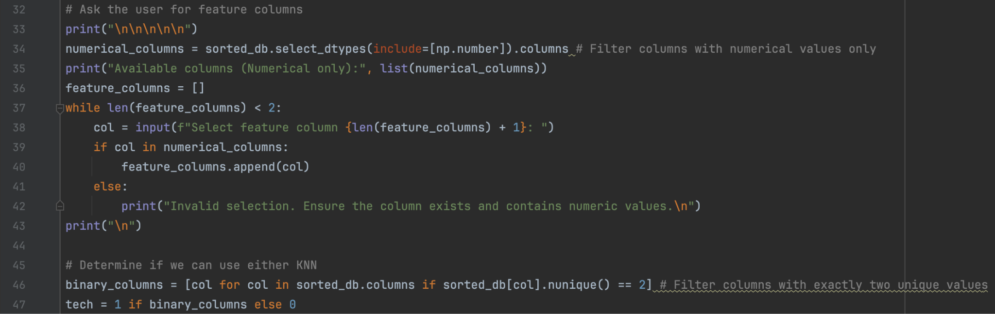
Supervised Learning: KNN Classification
If the dataset has a binary target column (like "0" for benign and "1" for malignant), the script uses the K-Nearest Neighbors (KNN) method for classification. Here's how it works:
- Selecting the Target Column: You choose the column that contains the labels (the target values).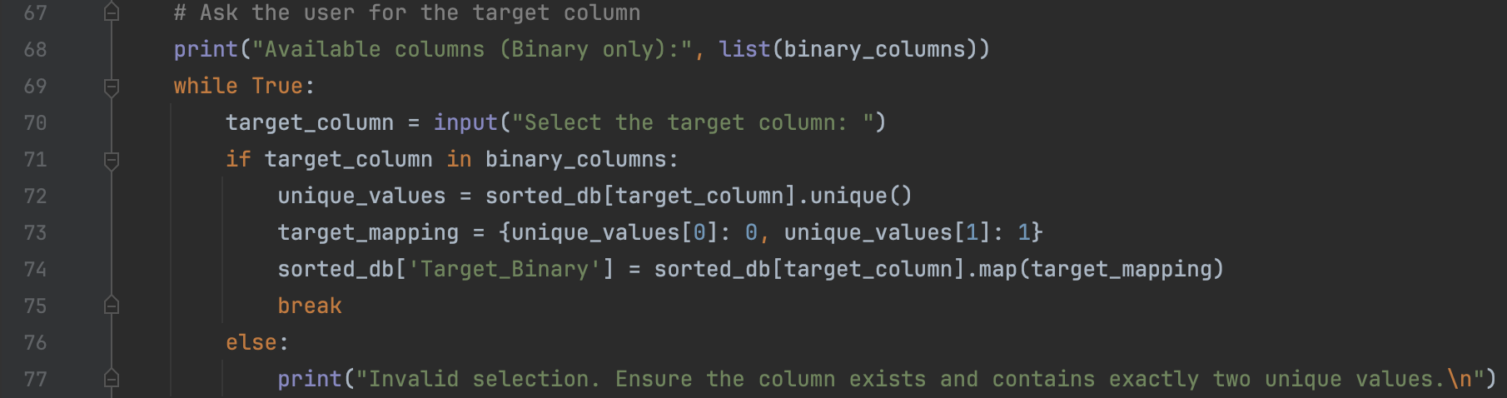
- Splitting the Data: The dataset is split into:
  - Training Data: Used to teach the model.
  - Testing Data: Used to check if the model is accurate.
- Training the Model: The KNN algorithm learns from the training data by looking at the nearest neighbors of each data point.
- Testing the Model: The model predicts the labels of the test data, and we check its performance.
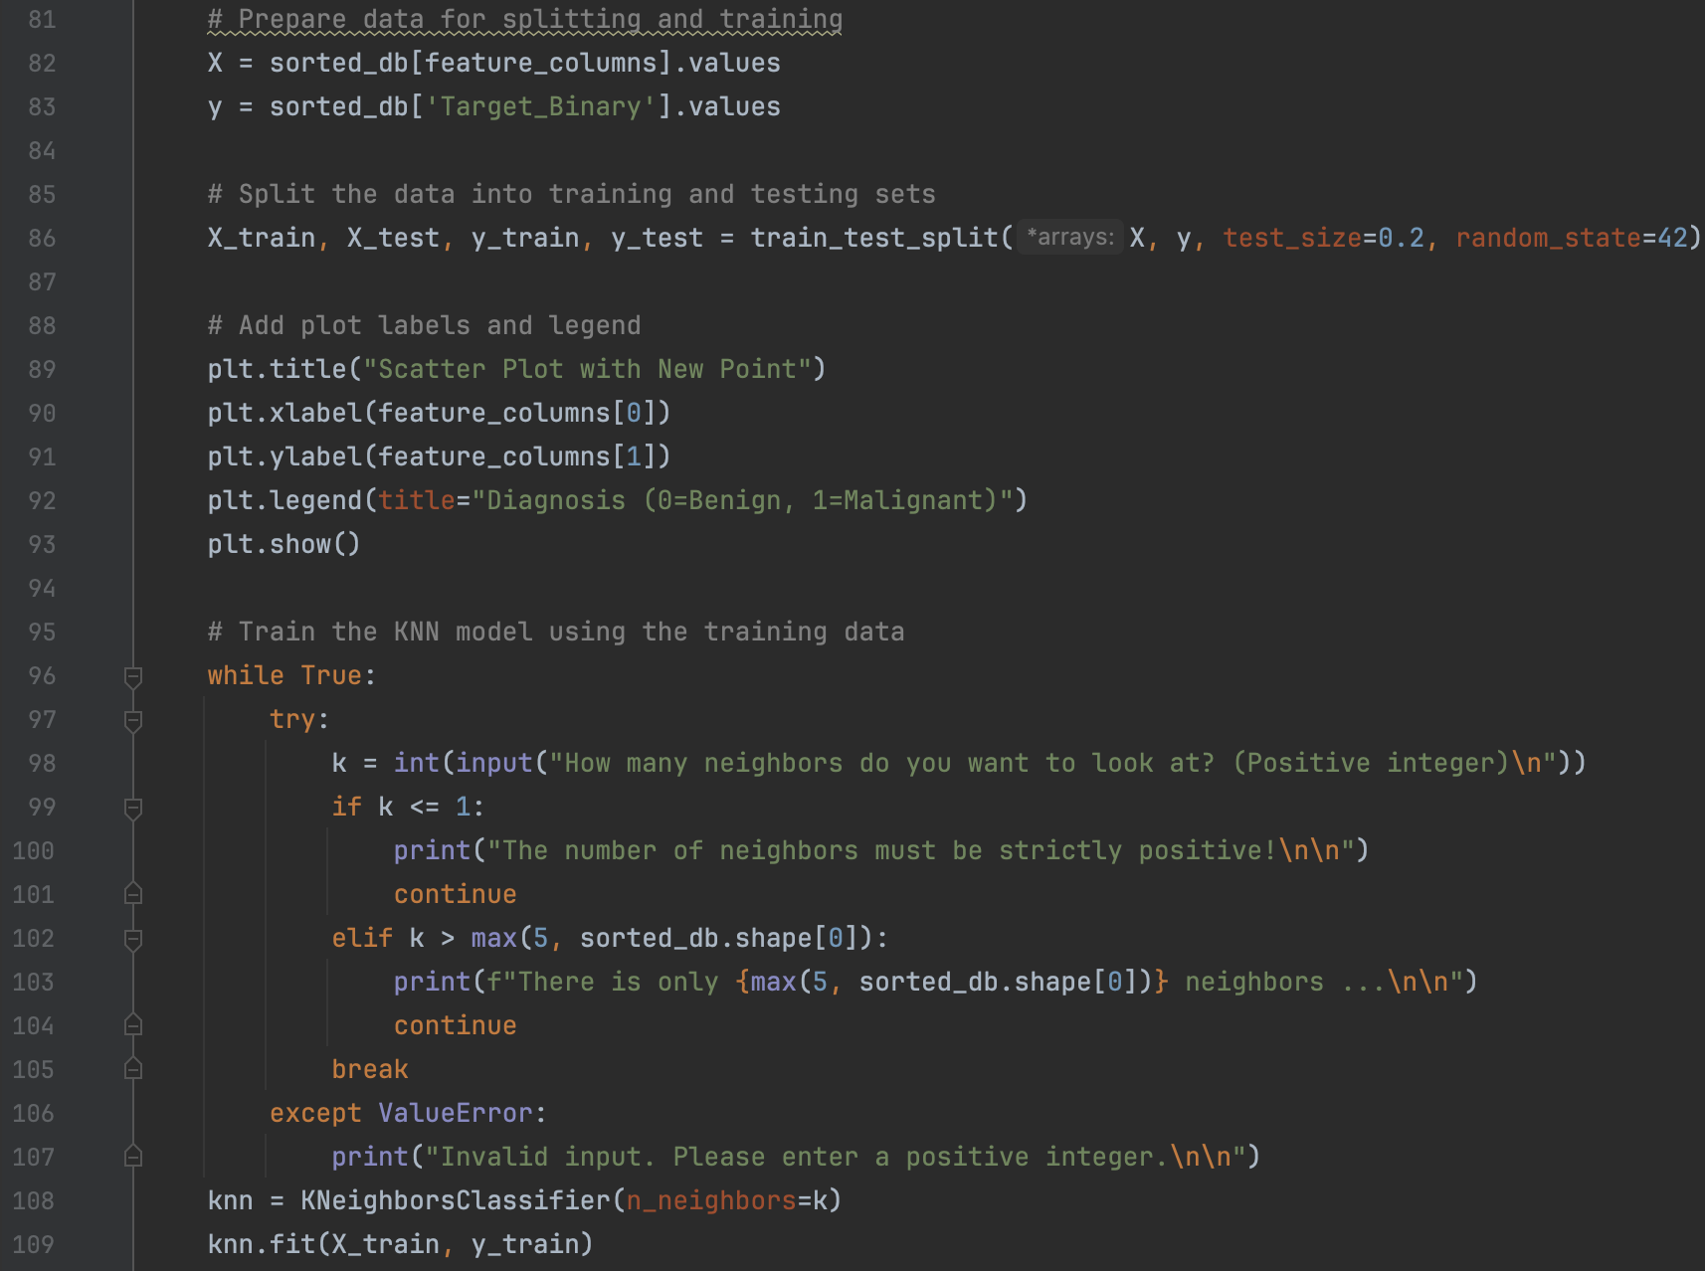
- Metrics and Visualization:
  - The script calculates accuracy, precision, and detection rate to measure how good the model is.
  - It generates a random data point, predicts its label, and plots it with the dataset so you can see how the model works.
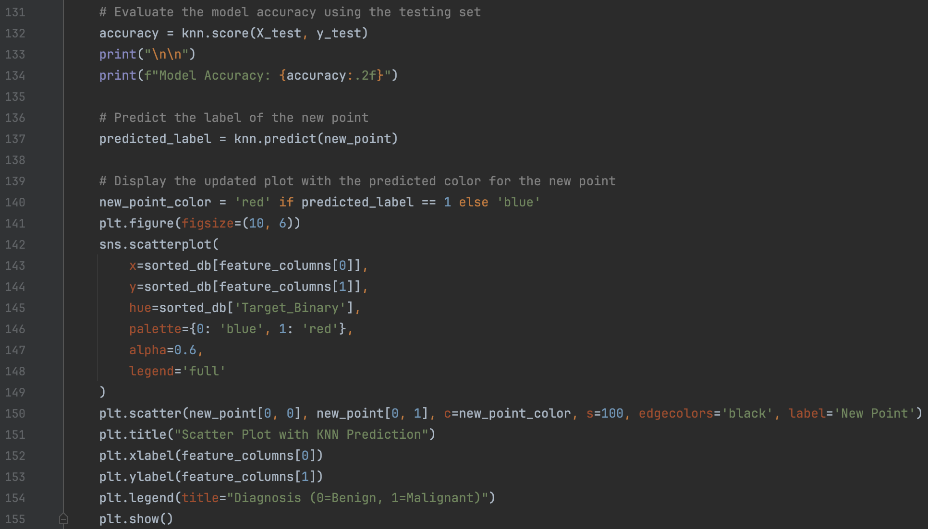

Unsupervised Learning: K-Means Clustering
If the dataset doesn’t have a target column, the script uses K-Means Clustering to group similar data points together. Here’s the process:
- Choosing the Number of Clusters: The user specifies how many groups (clusters) they want, with the default being three.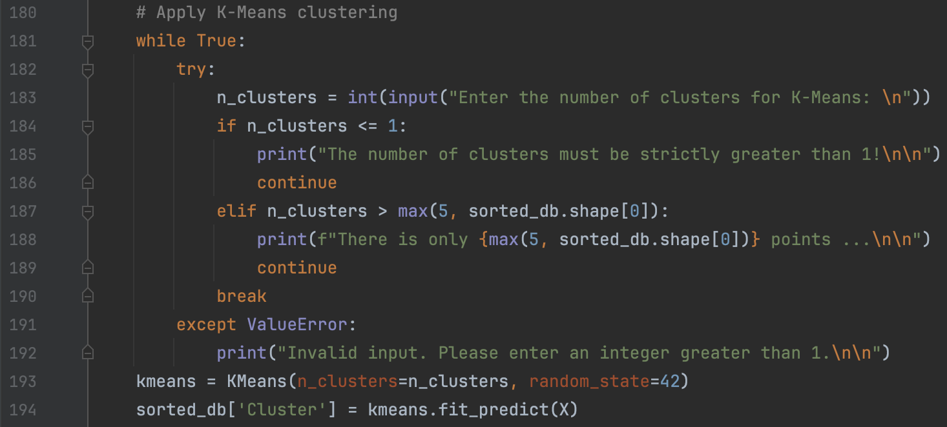
- Assigning Data to Clusters: The K-Means algorithm groups the data points and calculates the centroid (center) of each cluster.
- Evaluation: The quality of the clusters is measured using:
Silhouette Coefficient
The Silhouette Coefficient is a way to check how good the clustering is by seeing how well the clusters are separated. It looks at two things: how close a point is to other points in the same cluster and how far it is from points in the nearest other cluster. The score ranges from -1 to 1. A score near 1 means the clusters are clear and well-separated, 0 means the clusters overlap, and negative values mean the point might be in the wrong cluster. By averaging the Silhouette Coefficient for all points, we can tell how good the overall clustering is.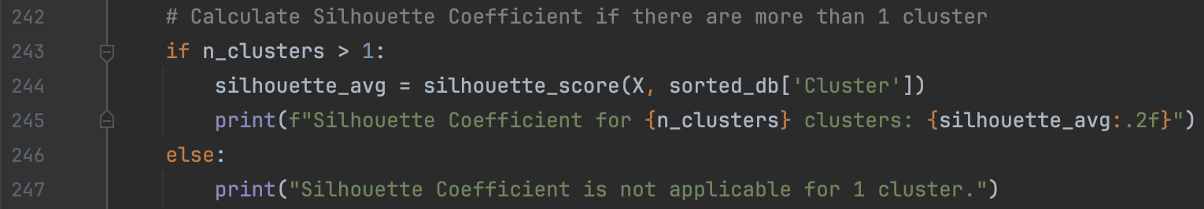
Elbow Method
The Elbow Method is a simple way to figure out the best number of clusters (k) for K-Means. To use it, you run the algorithm with different k values and calculate the Within-Cluster Sum of Squares, which shows how close the data points are to the center of their cluster. Then, you make a graph with kk on the x-axis and WCSS on the y-axis. The graph will usually have a steep drop at first, and then the decrease slows down, creating a shape like an "elbow." That "elbow" is where the best k is, because it gives good clustering without adding unnecessary complexity.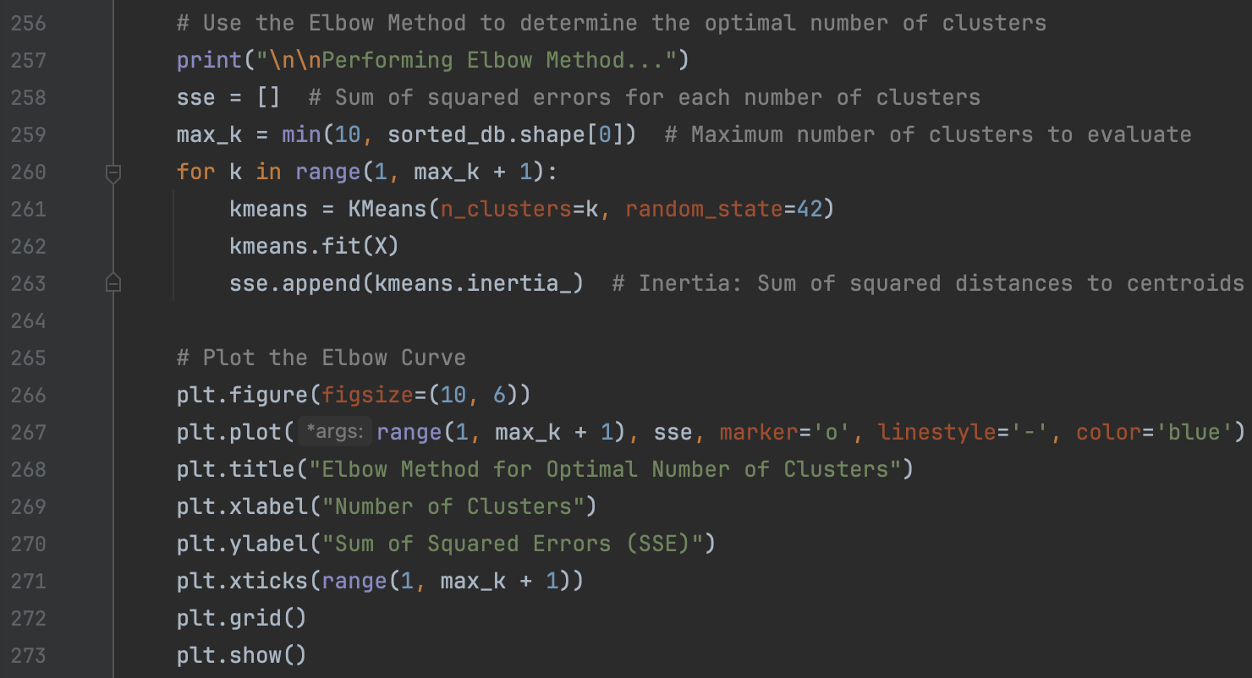

- Visualization: The results are shown in a scatter plot, where you can see the clusters and their centroids.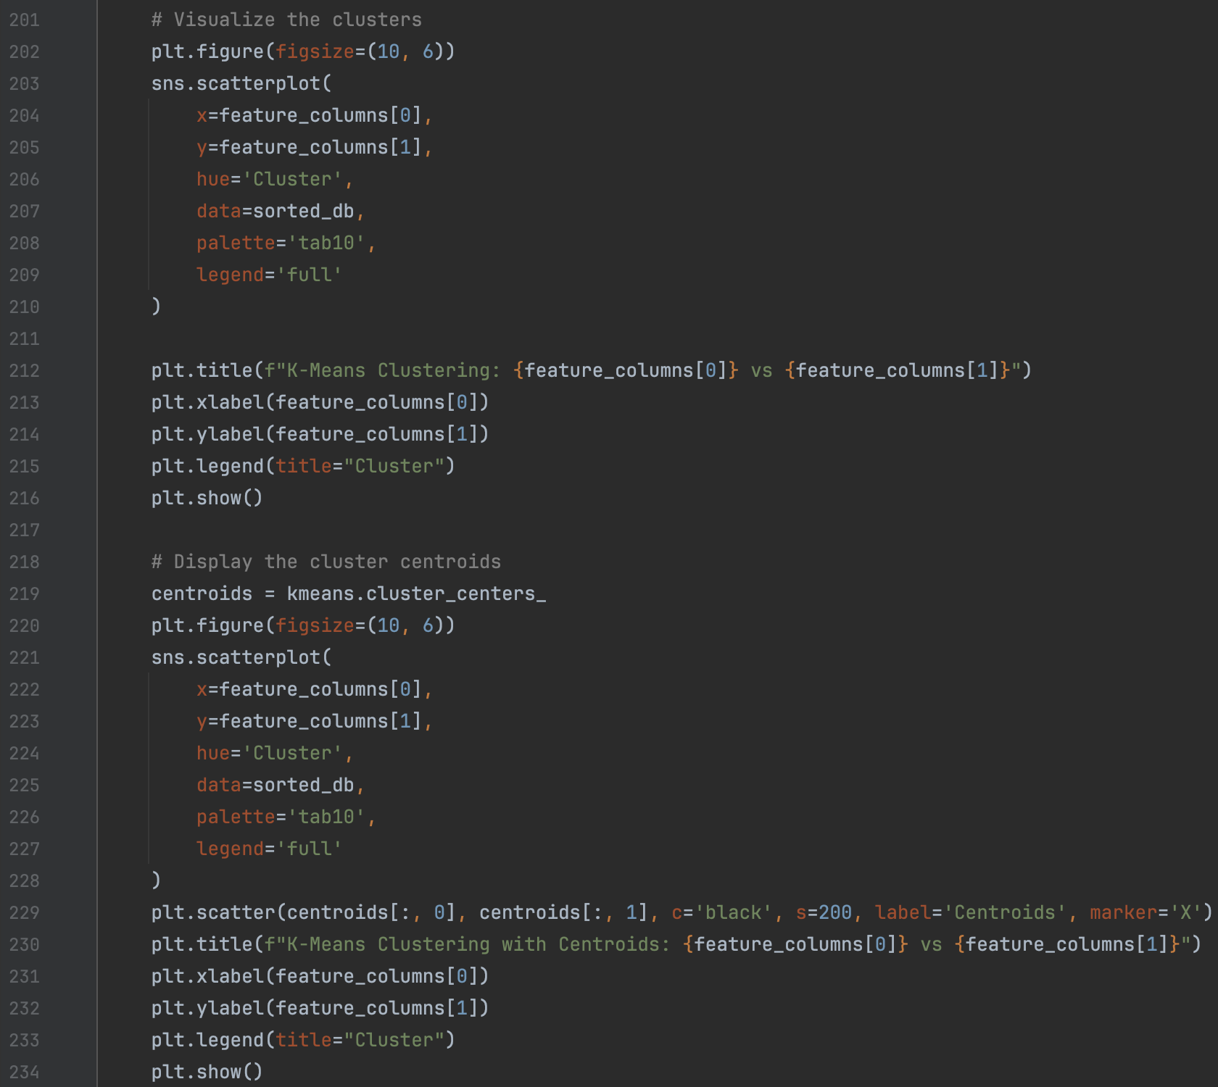
Preprocessing and Improvements
To make sure everything works smoothly:
- Missing values are handled to avoid errors.
- Only numerical features are used, so the models can process the data.
- In the future, we could add feature scaling to improve accuracy, since KNN and K-Means rely on distances between points.
Evaluation
- For KNN, we use a confusion matrix and calculate accuracy, precision, and detection rate to see how well the model predicts.
- For K-Means, we focus on clustering metrics like the Silhouette Coefficient and use the Elbow Method to optimize performance.

Summary
This project shows how Supervised Learning (KNN) and Unsupervised Learning (K-Means) can be used to analyze structured data. KNN helps predict outcomes for labeled data, while K-Means groups unlabeled data to find patterns. Both methods are useful for different purposes, and our script provides a simple way to explore and analyze datasets effectively.
By preprocessing the data carefully and evaluating the results thoroughly, we make sure the insights we get are reliable and actionable.

